Abstract
This study builds a multiple linear regression model to explain 1970 Boston housing prices using 13 predictors across demographic, structural, accessibility, and pollution categories. The final model, with fewer than ten variables, highlights demographic factors and air pollution as key drivers of housing value. Despite some assumption violations, the model achieved strong predictive performance (R² ≈ 0.81) through cross-validation, offering insights into historical housing dynamics and implications for future policy.
Simple Boston Housing Price Model
Sai Nikhil Chanda, Townes DeGroot, Jordan Alexander

Introduction
In the mid-1970s, two researchers attempted to model the effects of air pollution on housing prices and express the benefits of clean air in monetary units. These researchers utilized data from the Boston Standard Metropolitan Statistical Area (SMSA) Census and eventually published their results in the Journal of Environmental Economics and Management in 1978. They found that there were methodological problems with other similar studies and concluded that the value of clean air within housing prices had previously been overstated. Their analyses, however, did not particularly focus on the general relationship affecting housing prices in 1970 Boston. In the upcoming model, we take up this challenge and seek to design a multiple linear regression (MLR) model of 1970 housing prices in the Boston area using data that is publicly available on Kaggle, an online community for machine learners, developers, and researchers.
The dataset we are using to construct our model contains 506 observations of 14 variables, 13 predictors and 1 response. These 13 predictor variables measure four different descriptive categories about the housing tracts in the dataset. Eight of the thirteen variables describe an aspect of the neighborhood in which the housing tract is in. Two more of them measure the structural components of each housing tract. Only one variable measures the pollution near each housing tract, and the final two variables measure the housing tract’s accessibility to local areas. The presence of such clearly defined categories leads us to formulate multiple research questions about how these categories generally described Boston housing prices at the time of the census.
With our model, we seek to answer the following research questions:
- Which variable from each of the 4 categories is the most important in explaining median tract price?
- Which category contains the most important factors in explaining median tract prices?
- Are the variables within the neighborhood characteristics category significantly correlated?
Regarding these guiding research questions, we hypothesize the following:
- The variables “chas”, “tax”, “dis”, and “lstat” are expected to have the most marginal impact on predictive power for each of the four defined variable categories.
- Location is expected to be the most important variable category in predicting median housing tract prices, but we hypothesize that at least one variable from each category will also be preserved in the final model.
- We expect the neighborhood characteristic variables to be significantly correlated with each other. Due to historical practices of redlining within Boston and 1970 economic practices, we expect the variables measuring the crime rate, non-retail business proportion, pupil-teacher ratio, Black population, and low-status population to all be significantly correlated.
Data Exploration
As previously mentioned, the dataset contains 506 observations of 14 variables. Each observation contains housing information within distinct land tracts from the Boston area. These variables are mostly quantitative, and while they all follow different density distributions and take on different ranges of values, the differences in scale were small enough not to raise any concerns of potential roundoff errors during the model fitting process. Figure 1 in the Appendix is a table that provides further insight into each variable, including its coded name, description, type, category, and sample values. Furthermore, figures 2–14 in the Appendix display histograms for each of the thirteen predictor variables.
“Medv” is our response variable, which measures the median value of houses (in thousands of dollars) within each observed tract. To begin our analysis, we explore the simple linear relationships between each of the explanatory variables and our response variable. These scatterplots reveal clear non-linear relationships between our response variable and several predictors, such as “lstat” and “dis”. These plots are displayed below, but the scatterplots for all other variables are listed as Figures 15–27 in the Appendix.
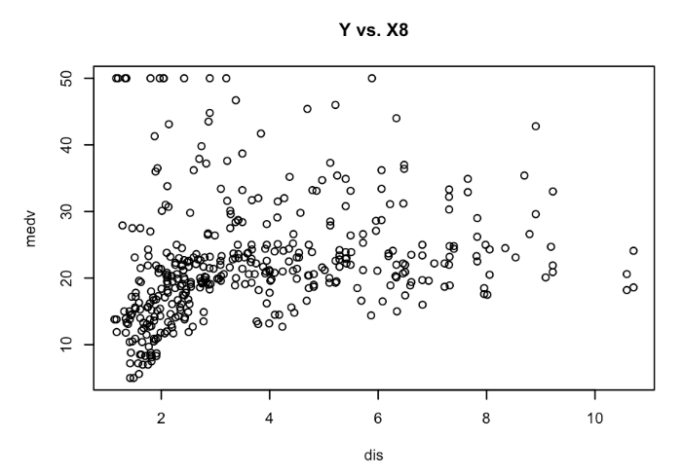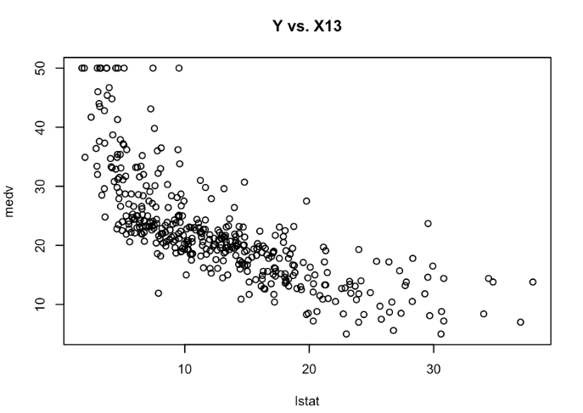
Figures 22 and 27: Scatterplots of Y (medv) against the predictors X8 (dis) and X13 (lstat).
Due to these non-linear relationships, we explore transformations of both our predictor and response variables in creating our final model of Boston housing prices. Pursuant to our third research question, we also investigated the degree of correlation between our predictor variables, specifically those within the same categories. We found that the two location variables had a significant correlation coefficient of –0.483, and the two structural variables also had a significant correlation coefficient of –0.226. As for the largest variable group, the neighborhood characteristics category, only 6 out of the 28 variable relationships had an insignificant correlation coefficient, all of which came from X4’s relationships to other variables. This, coupled with the binary nature of X4 and the lack of a clear statistical relation between X4 and Y, suggests that X4 cannot capture the variation in median home value and will not be significant to our final model. This assumption will be investigated further in our model-building process. Figures 28–30 in the Appendix show scatterplots and correlation matrices for each variable category except for air pollution because it is a category of only one variable and therefore has a perfect correlation with itself.
Our final data investigation was into the distribution of “medv” or Y, our response variable. In many economic analyses, variables measuring prices are transformed using a base-10 logarithm or a natural logarithm. This occurs because price variables often have a well-defined floor but no ceiling, so the distribution of the data is often right-skewed. In the case of this dataset, a natural logarithmic transformation did appear to improve the linearity of many relationships between Y and the predictors. It also made the distribution of “medv” more normal, which can be observed below in the histograms of “medv” before and after its transformation. In the Appendix, Figures 33–45 show new scatterplots between the transformed response variable and the 13 predictors.
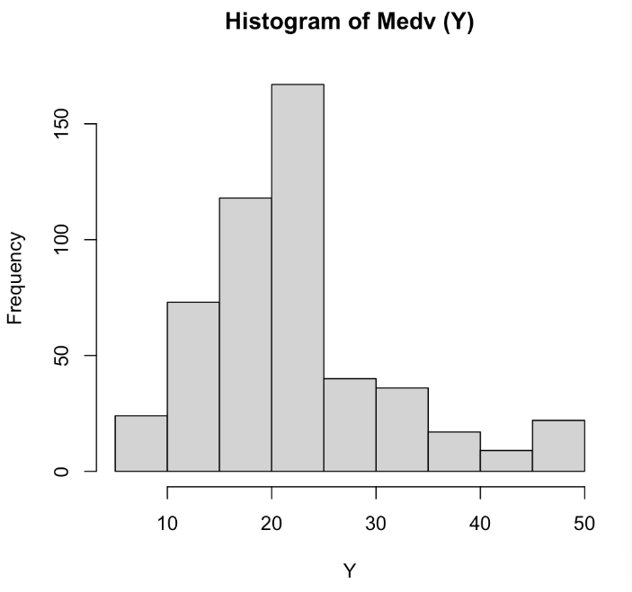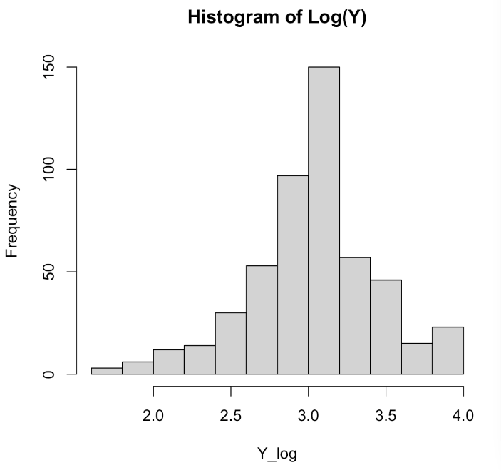Figures 31 and 32: Histogram of the response variable “medv” before and after a logarithmic transformation.
Overall, exploring the distributions of the variables and transformations that improve linearity provides a solid foundation to fitting a multiple linear regression model with less than 10 terms.
Regression Analysis
The final regression formula that best fit our data was:
$$\log\left(Y\right) ∼ x_{1} + x_{5}+x_{6}+x_{11}+x_{13}+\log{x_{8}}+\left(x_{1}⋅x_{5}\right)+\left(x_{6}⋅x_{11}\right)+\left(x_{11}⋅x_{13}\right)$$
When trained against our training set with k-fold cross-validation, it produced the following linear model:
$$\log\left(Y\right)=3.439+0.00197⋅x_{1}-0.947⋅x_{5}+0.119x_{6}-0.0313⋅x_{11}-0.0249⋅x_{13} \\ -0.213⋅\log{x_{8}}-0.0916⋅\left(x_{1}⋅x_{5}\right)-0.0439⋅\left(x_{6}⋅x_{11}\right)-0.00398⋅\left(x_{11}⋅x_{\left(13\right)}\right)$$
In this model, each predictor variable is centered around 0 to reduce multicollinearity. We can readily observe that the most significant variables are nitrogen oxide concentration (X₅), average number of rooms per dwelling (X₆), weighted distance from employment centers (X₈), pupil-teacher ratio (X₁₁), and percentage of lower status population (X₁₃). The per capita crime rate (X₁) is included in the model because the interaction term is significant, however the variable itself is not significant. Figure 46 below displays the 95% confidence intervals for each term in the model.
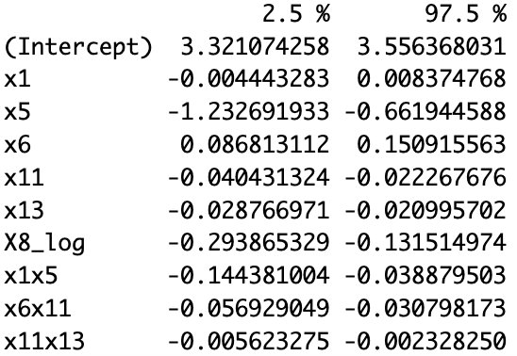
Figure 46: 95% Confidence Intervals for model coefficients.
The coefficients of the variables make intuitive sense. x₅, x₁₁, log(X₈), and x₁₃ have negative coefficients because those variables represent attributes often associated with geographic poverty, and one would expect that any increase in those variables would lead to a decrease in median home value. For example, it makes intuitive sense that a more polluted area, represented by nitrous oxide concentration (x₅), would see a decreased median home value. Additionally, the x₆ coefficient is positive, which maps to our understanding of home value because bigger houses typically have more rooms and are more expensive. x₁'s coefficient is positive, meaning a higher neighborhood crime rate is associated with increased home value. While this does not intuitively make sense, we know that x₁ is only in the final model for interpretability because the interaction term x₁*x₅ is. The 95% confidence interval for x₁’s coefficient includes 0, and the variable holds absolutely no significance, so x₁’s coefficient may be treated as meaningless.
The final model was derived from automatic model selection procedures, such as forward and backward stepwise regression and the best subsets algorithm. Overall, this project focuses on deriving an accurate yet simple model with fewer than 10 predictor variables, which we achieved. First, we identified the significant base variables and tested them against different transformations of the response variable. Eventually, we found that a log transformation of Y was appropriate, and we identified x₁, x₅, x₆, x₁₁, and x₁₃ as significant. Then, we tested transformations of the other variables to see if they would improve the model, and we found that log(X₈) was the only significant transformed term. Finally, we looked at graphs of every possible interaction term and then performed another analysis to determine the best interaction terms to include that kept the model with fewer than 10 predictor variables.
After selecting our final regression model, we calculated multiple metrics and performed hypothesis tests to investigate the model assumptions of normally distributed, independent errors with constant variance and no multicollinearity among predictor variables. Based on the various metrics and test statistics, we concluded the following:
- The error terms are not normally distributed.
- The error variance is not constant.
- The errors are independent
- The variables in the model have high multicollinearity values, based on the variance inflation factor (VIF).
The plots below provide further insight into where these conclusions come from.
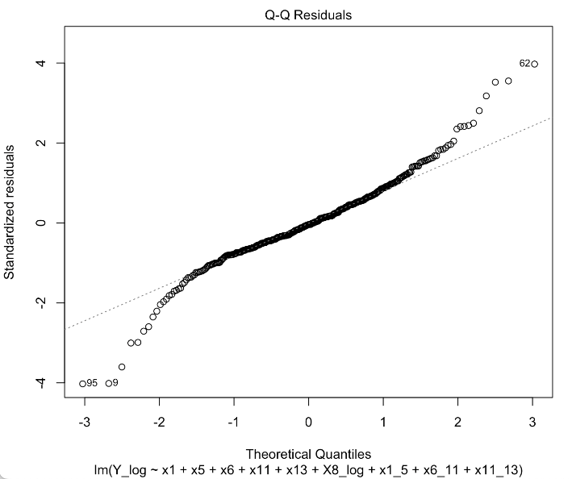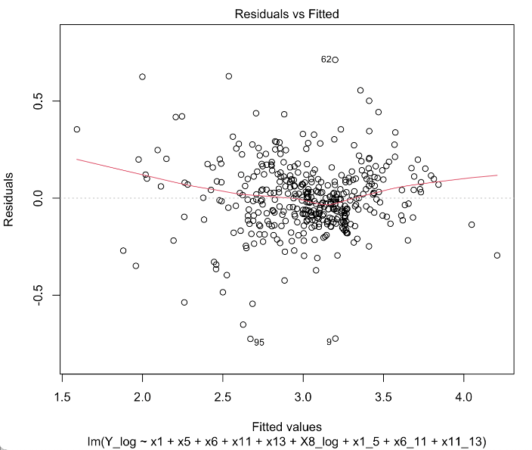
Figure 47: Normal Probability Plot of Residuals for Final Model, Figure 48: Residuals vs Fitted Values for Final Model
The failed model assumptions and the plots above reveal the necessity of outlier analysis for our model. Using leverage and studentized deleted residual values, we identified 43 outlying cases in our training dataset of 405 observations. Then, upon analyzing DFFITS, DFBETAS, and Cook’s Distance values for each of these cases, we identified 16 total influential points in our training set to consider eliminating. Within the entire data set, we conducted this same process and identified an additional 3 values, bringing our influential case total to 19 cases within 506 observations. By removing these cases, we saw a decrease in multicollinearity to within acceptable parameters. However, our model’s R² value decreased, and we still could not satisfy the assumption of having normal errors with constant variance. Furthermore, our model’s predictive power, measured by $\sqrt{{MSPR}/{MSE}}$ changed by 0.16. This caused us to suspect some level of data split bias from the initial split of our dataset into training and validation datasets.
To address this, we performed k-fold cross-validation with 5 folds of approximately 101 observations each to analyze the predictive ability of our model. After this cross-validation, our model had an R² value of 0.8117 and the model was able to generalize very well to the new training data, though the failed model assumptions provide a caveat to this.

Discussion and Limitations
The final model provides good insights into all our research questions. The percentage of lower-status population (x₁₃) is the most significant of the neighborhood demographic variables. Nitrogen oxide concentration (x₅) is the only pollution variable, so it is automatically the most significant. The average number of rooms per dwelling (x₆) and distance from employment centers (x₈) are the most significant structural and accessibility variables, respectively. The most important category for determining the median housing value was the neighborhood demographic category, which both x₁₁ and x₁₃ came from. As mentioned in the data exploration, all variables were correlated with all other variables in their groups, except for X₄.
Despite our model predicting and validating well, there are some limitations to it. Firstly, we deliberately chose not to make the most powerful and predictive model. This was due to fear of overfitting and diminished interpretability of our model. We decided that we wanted to make the best model given the constraint that it had to be simple, specifically less than 10 predictor variables. During our initial data analysis, we constructed models that were more accurate, some with adjusted R² values of greater than 0.9, but they also had many more predictor variables, which made the models ultimately unintuitive. Comparing our initial complex models to the simple model we uncovered, we were able to decrease our model size by around 25-30 terms while only decreasing our adjusted R² value by about 0.1. This trade-off is one we are happy to make, as it highlights the most important factors driving 1970s Boston house prices.
Given the final model failing to satisfy the assumptions of normal errors with constant variance, even after outlier analysis, our model’s prediction accuracy is impacted. These specific assumptions allow for precise inference statistics and coefficient confidence intervals. However, due to the large sample size of our dataset, these concerns are not enough to significantly confuse our analysis. All that we can conclude is that the data is not suitable for a linear regression model, so a more complex model should be used, or more extreme remedial measures should be taken, such as iteratively weighted least squares regression. We can at least be sure that the data itself is fairly reliable, as it is from a government department that we assume to have proper data collection procedures.
Clearly, the model’s failure to satisfy some assumptions caused concern. Beyond the high correlation between predictor variables, the non-linear relationships and obscure distributions of some predictor variables could have affected the residuals. Future work should conduct more analysis on remedial measures to make the model more methodologically sound and reliable for inference and prediction statistics. By conducting Brown-Forsythe tests where the data is split based on certain predictors and their values, we could uncover if there are certain groups that produce different residual variances. Creating new categorical variables by binning our discrete predictors could give more options as to what variables to add in our model, and could help capture more residual variance. For example, we binned the variable “age” in 4 groups: (0-25), (25-50), (50-75), and (75-100). While this proved somewhat unhelpful, more analysis in this direction could help uncover the causes behind the model’s non-constant and non-normal variance.
In understanding the appropriateness of our regression analysis, the failure of most assumptions lessens the reliability and predictive capabilities of our model. However, our simple model was able to capture sufficient variance without overfitting our model by adding 20+ variables. By focusing on select variables, we were forced to only include key predictors, such as the variables listed in the previous paragraph. Through outlier analysis, we were able to take out a significant number of influential outliers, allowing for a more accurate result. Based off other analyses and models designed for this data, using a Decision Tree or a Random Forest model produced a better R², but had significantly larger MAE and MSE values compared to our Linear Regression. This could be due to these complex models’ overfitting, just as our original MLR model contained 40 variables.

Conclusion
The central goal of our project was to create the best multiple linear regression model with less than 10 predictor variables to understand the 1970s Boston housing market. We tested a variety of models with fewer than ten predictor variables and finally produced a model that had problems with constant variance and normal residuals, but possessed good predictive power. In an attempt to remedy the model’s issues, we performed outlier analysis and were able to take out 19 influential cases, which helped increase R² and decrease our non-constant variance and MSE. We also conducted a K-fold cross validation process in the hopes of increasing our model’s ability to generalize, which we were able to achieve. There are some limitations to our model that could be addressed in the future and ways we could work to overcome the non-constancy of error variance, but our model is useful and met our initial goals.
We learned from our model that demographic information was the most important predictor of median housing value, but pollution, represented as nitrogen oxide concentration, did a good job in predicting housing prices. We cannot state to what extent more pollution causes lower housing prices, though intuitively there appears to be a connection there. This does pose a significant problem for modern-day public policy, as pollution has only increased since 1970. Performing a similar study on modern-day housing value would give us a lot of information about how housing value has changed over the years and if any of the most significant predictor variables have changed.

Additional Work
In the process of discovering our final model, we went through many iterations of trial and error, which we will show here. Our first two models were when we did a forward and backward step regression from a pool of all possible variables (first-order, second-order, and interaction). These processes created models with 30-40 variables each, which were difficult to analyze, especially considering our research questions. We then created the model below, only containing first-order terms.
$$Y ∼ X_{1}+X_{2}+X_{3}+X_{4}+X_{5}+X_{6}+X_{7}+X_{8}+X_{9}+X_{10}+X_{11}+X_{12}+X_{13}$$
From this model, we noticed that X₃ and X₇ were not significant, and X₉ proved to be insignificant as well from the ANOVA table. To make sure X₃, X₇, and X₉ were insignificant, we ran the same model with $\sqrt{Y}, \log_{10}{Y}, \ln{Y}$. Even after running these models, the same situation occurred, and we noticed that$\log_{10}{Y}$ proved to be the best transformation in terms of MSE and R². Another thing we noticed was that X₉ and X₁₀ showed high multicollinearity, which made it
$$\log_{10}{X_{1}}$$ | $$\log_{10}{X_{8}}$$ | $$\log_{10}{X_{1}}* \log_{10}{X_{8}}$$ | $$\log_{10}{X_{5}}* \log_{10}{X_{8}}$$ | $$X_{6}* X_{7}$$
$$X_{13}^{2}$$ | $${{(log}_{10}{X_{1}})}^{2}$$ | $$\log_{10}{X_{5}}*X_{4}$$ | $$\log_{10}{X_{1}}* X_{11}$$ | $$X_{12}* X_{13}$$
$$\sqrt{X_{8}}$$ | $$\log_{10}{X_{5}}$$ | $$X_{13}*X_{6}$$ | $$\log_{10}{X_{8}}* X_{10}$$
clear that X₃, X₇, and X₉ should be taken out of the model.
We then went into testing various second-order, transformations, and interactions of our predictive variables, which are listed above. Of the 8 interaction terms, 5 of them are of different data types (i.e. neighborhood, structural, etc.), which were made to uncover any relations between the data categories. We used all these variables in Leaps regression subsets, with a maximum of 10 variables, where we chose the model based on the Cp and its associated adjR² value. From the Leaps code and our criteria, we uncovered this model shown below. There was extremely significant multicollinearity between X₁₃ and X₆X₁₃, meaning that one of them had to be taken out. Besides that, out model still had failed the test for constant variance and normality of residuals.
$$\log_{10}{Y} \sim \log_{10}{X_{1}}+ X_{4}+\log_{10}{X_{5}}+ X_{6}+ X_{12}+ X_{13}+ X_{13}^{2}+ \log_{10}{X_{1}}\log_{10}{X_{8}}+X_{13}X_{6}+\log_{10}{X_{5}}\log_{10}{X_{8}}$$
To help with the multicollinearity, we centered all the non-log variables (besides X₄ because it’s a dummy variable) and reran the model (without X₆*X₁₃), and there was no multicollinearity. However, we still needed to address the non-constant variance and normality issue. To investigate, we went back to X₇, a variable we discarded in the initial stages of our process, and created 4 categorical variables by binning X₇ into 4 distinct buckets. We also included some other transformations, such as $x_{11}^{2}, \sqrt{400- X_{12}}, x_{13}*\sqrt{400- X_{12}} , x_{5}^{2}$ , and each bucket from X₇ * X₆. With these additional variables, we ran the Leaps regression again, and after some significance testing, we came up with this model.
$$\log_{10}{Y} \sim \log_{10}{X_{1}}+ x_{5}+ x_{6}+\log_{10}{X_{8}}+ x_{11}+ x_{13}+x_{13}x_{6}+ \log_{10}{X_{1}}\log_{10}{X_{8}}+x_{6}X_{7_50-75}$$
While this model did include a categorical variable from X7, it did not help solve what was causing the non-constant variance. The MSE, R², and VIF values were significant, but we decided to scrap this model and move on, to see if we can improve the model’s interpretability. From here, we come to our final model, which we have shown throughout the paper.

Appendix
Figure 1: Summary of Boston Standard Metropolitan Statistical Area Census Dataset
Variable | Coded Name | Description | Type | Example Values
crim | X1 | Per capita crime rate by town | Numeric, Neighborhood | 0.006, 0.027, 0.069
zn | X2 | Proportion of residential land zoned for large lots | Numeric, Neighborhood | 18, 0, 12.5
indus | X3 | Proportion of non-retail business acres per town | Numeric, Neighborhood | 2.31, 7.07
chas | X4 | Charles River dummy variable (1 = tract bounds river; 0 = otherwise) | Integer, Neighborhood | 0, 1
nox | X5 | Nitrogen oxide concentration (parts per 10 million) | Numeric,  Air Pollution | 0.538, 0.469
rm | X6 | Average number of rooms per dwelling | Numeric, Structural | 6.58, 6.42, 7.18
age | X7 | Proportion of owner-occupied units built before 1940 | Numeric, Structural | 65.2, 78.9, 45.8
dis | X8 | Weighted distance to Boston employment centers | Numeric, Accessibility | 4.09, 4.97, 6.06
rad | X9 | Index of accessibility to radial highways | Integer, Accessibility | 1, 2, 5
tax | X10 | Property tax rate per $10,000 | Integer, Neighborhood | 296, 242, 311
ptratio | X11 | Pupil-teacher ratio by town | Numeric, Neighborhood | 15.3, 17.8, 18.7
b | X12 | Racial proportion (higher values indicate lower % Black population) | Numeric, Neighborhood | 397, 395, 393
lstat | X13 | Percentage of lower status population (maximum education level of high-school or temporarily employed) | Numeric, Neighborhood | 4.98, 9.14, 5.33
medv | Y | Median value of owner-occupied homes (in $1,000s) | Numeric, Dependent | 24.0, 21.6, 34.7

Figures 2–14: Histograms of all predictor variables in the Boston housing dataset
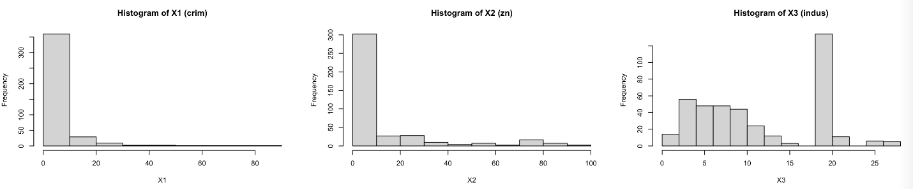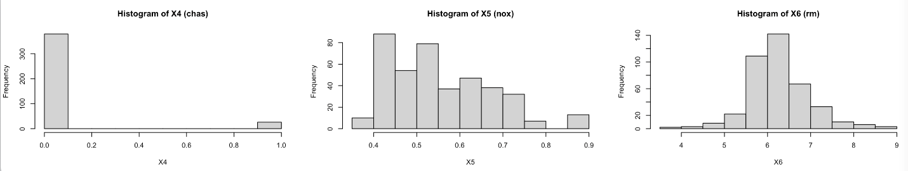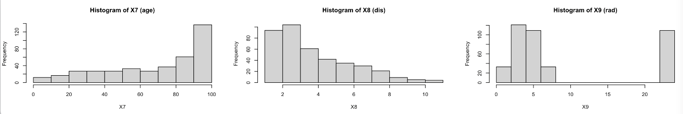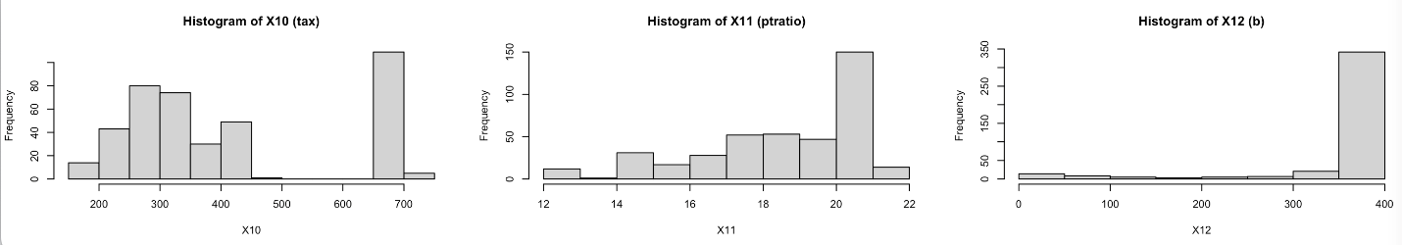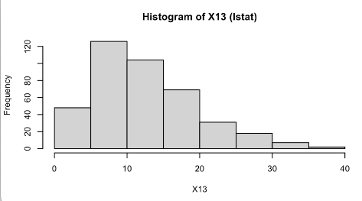

Figures 15–27: Scatterplots between median house value and all predictor variables.
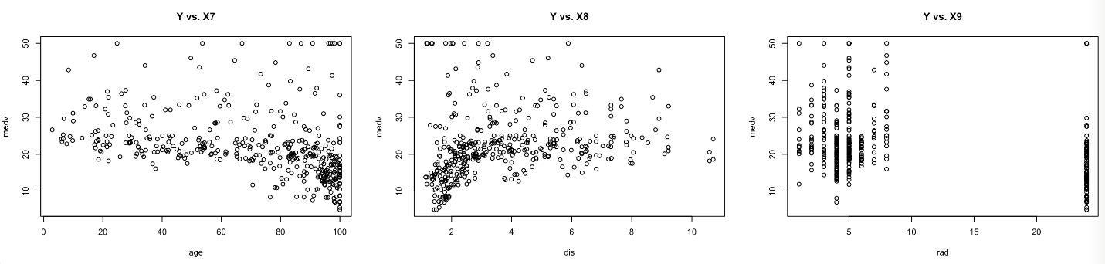
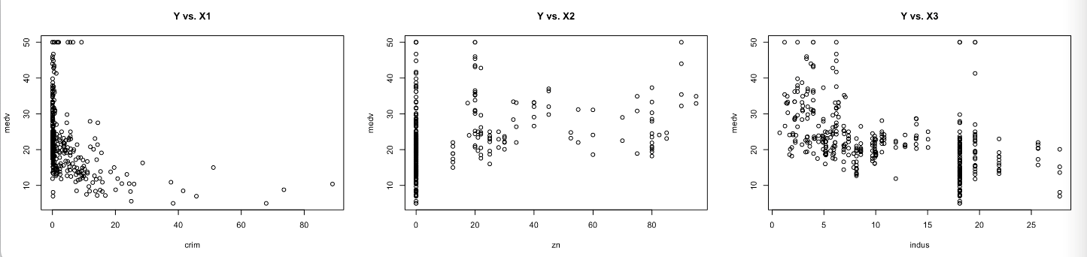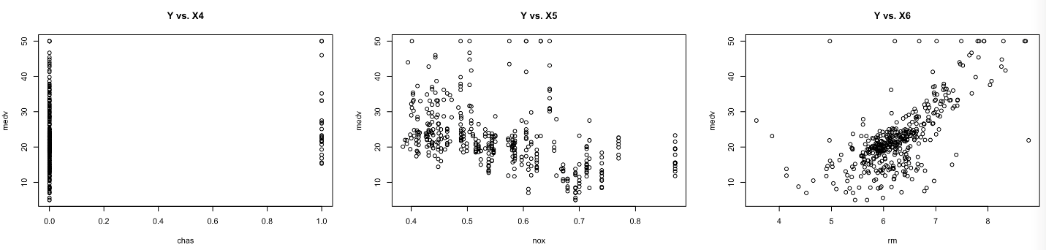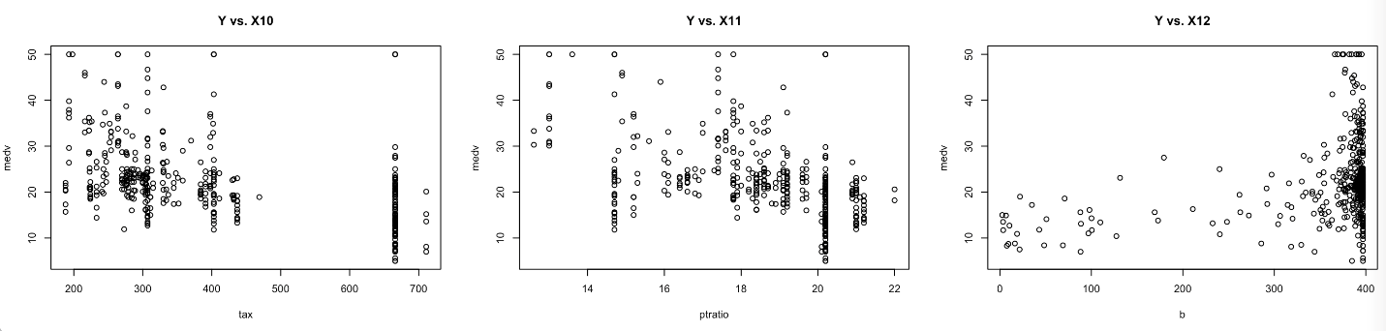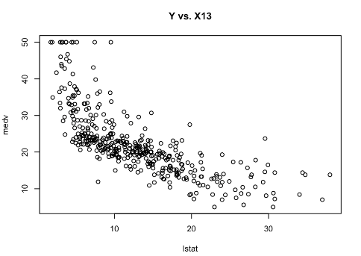
Figures 28–30: Scatterplot and correlation matrices of predictor variable categories
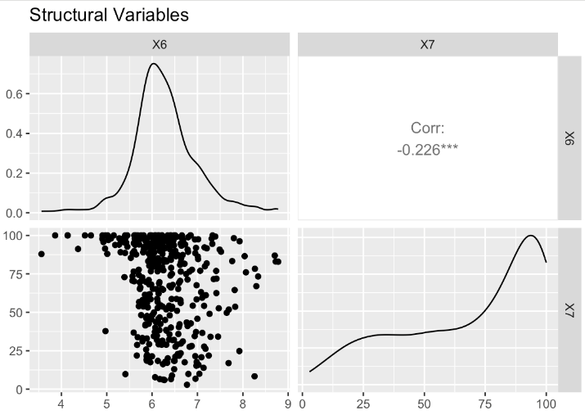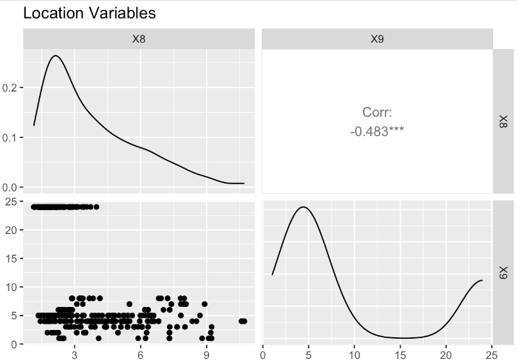
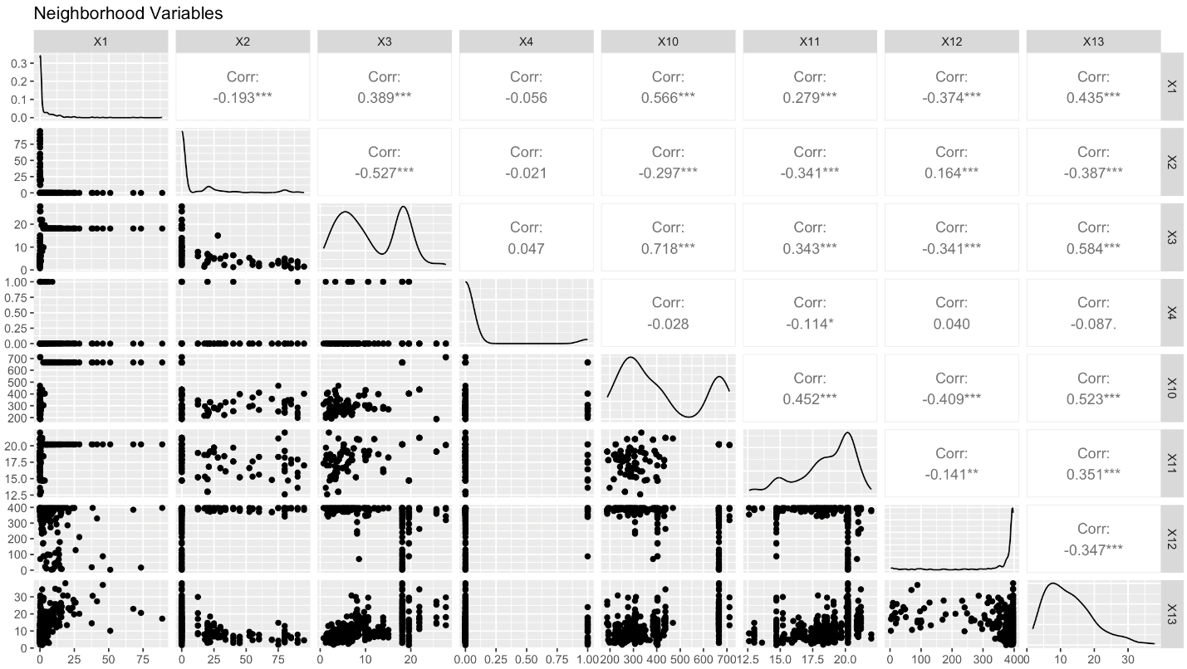

Figures 33–45: Scatterplots of Log(Y) vs all predictors
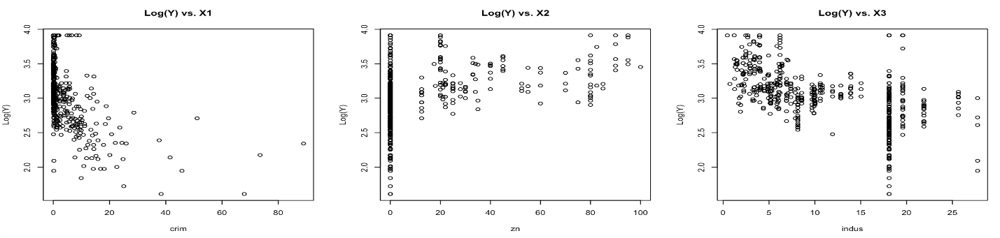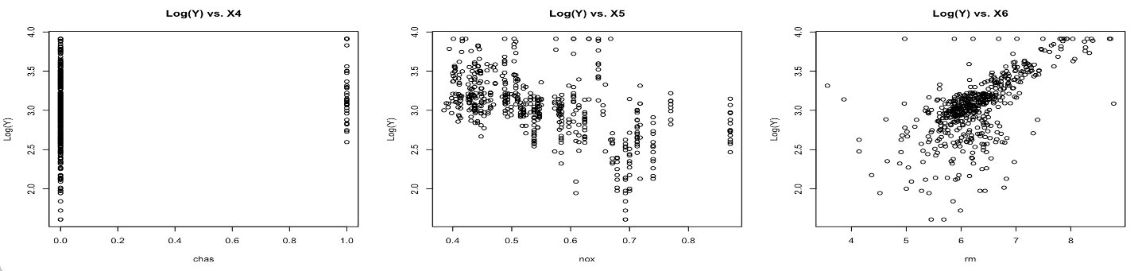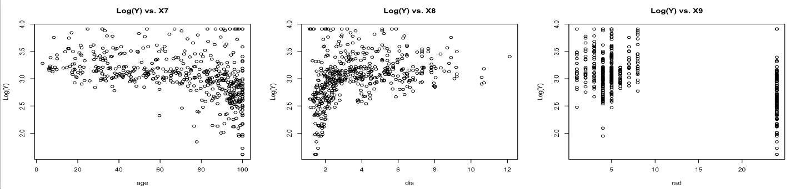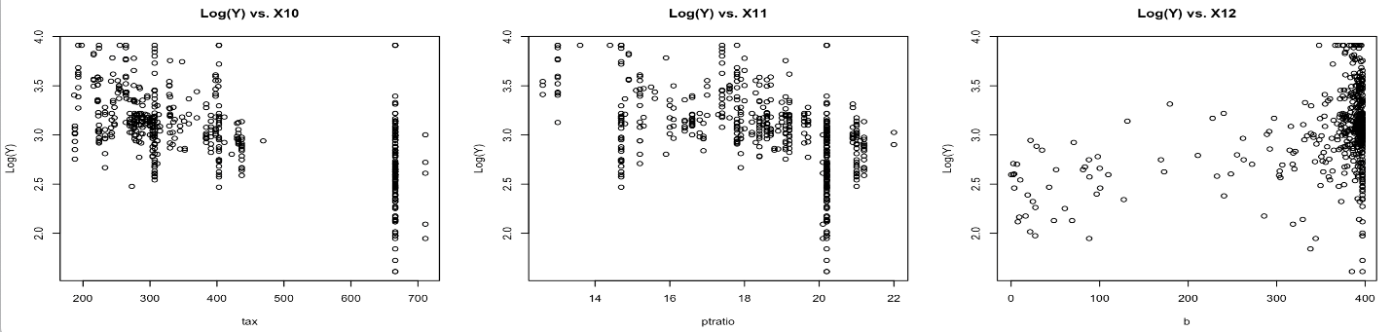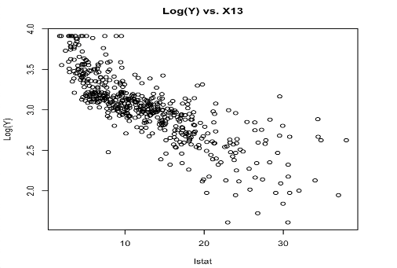
Figure 49: Our analysis function, which returns important information given a model
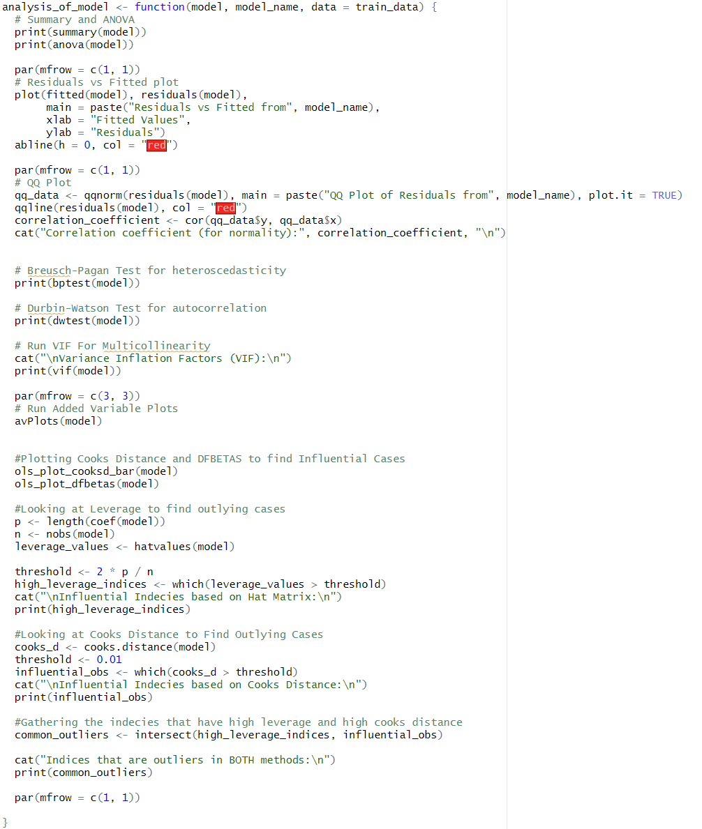

Figure 50 – Example code of transformations we made for our models
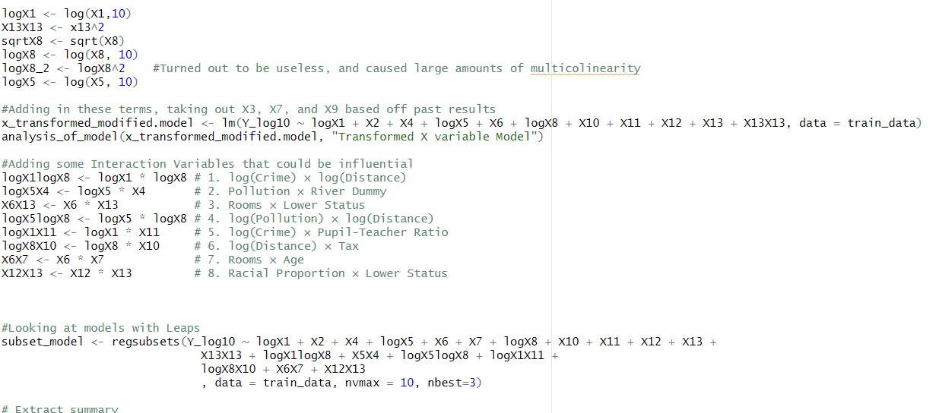

Figure 51: Outlier analysis for final model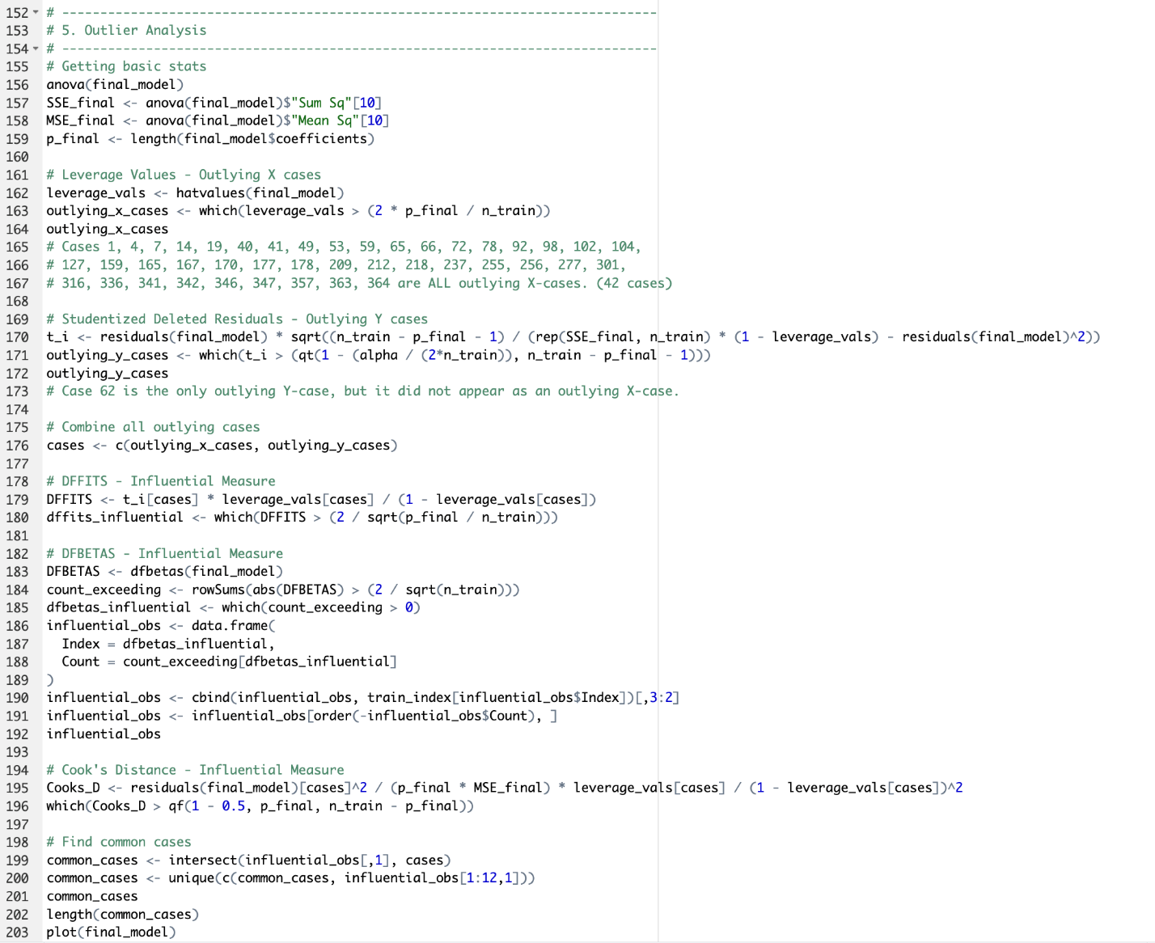

Figure 52: Code snippet of K-Fold Cross Validation for our final model
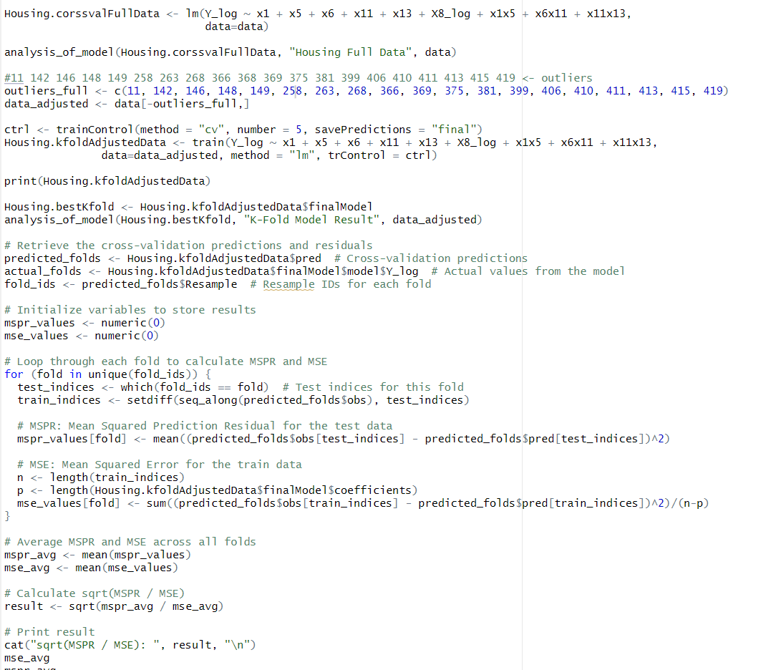

Figure 53: Part of the process of determining our final model
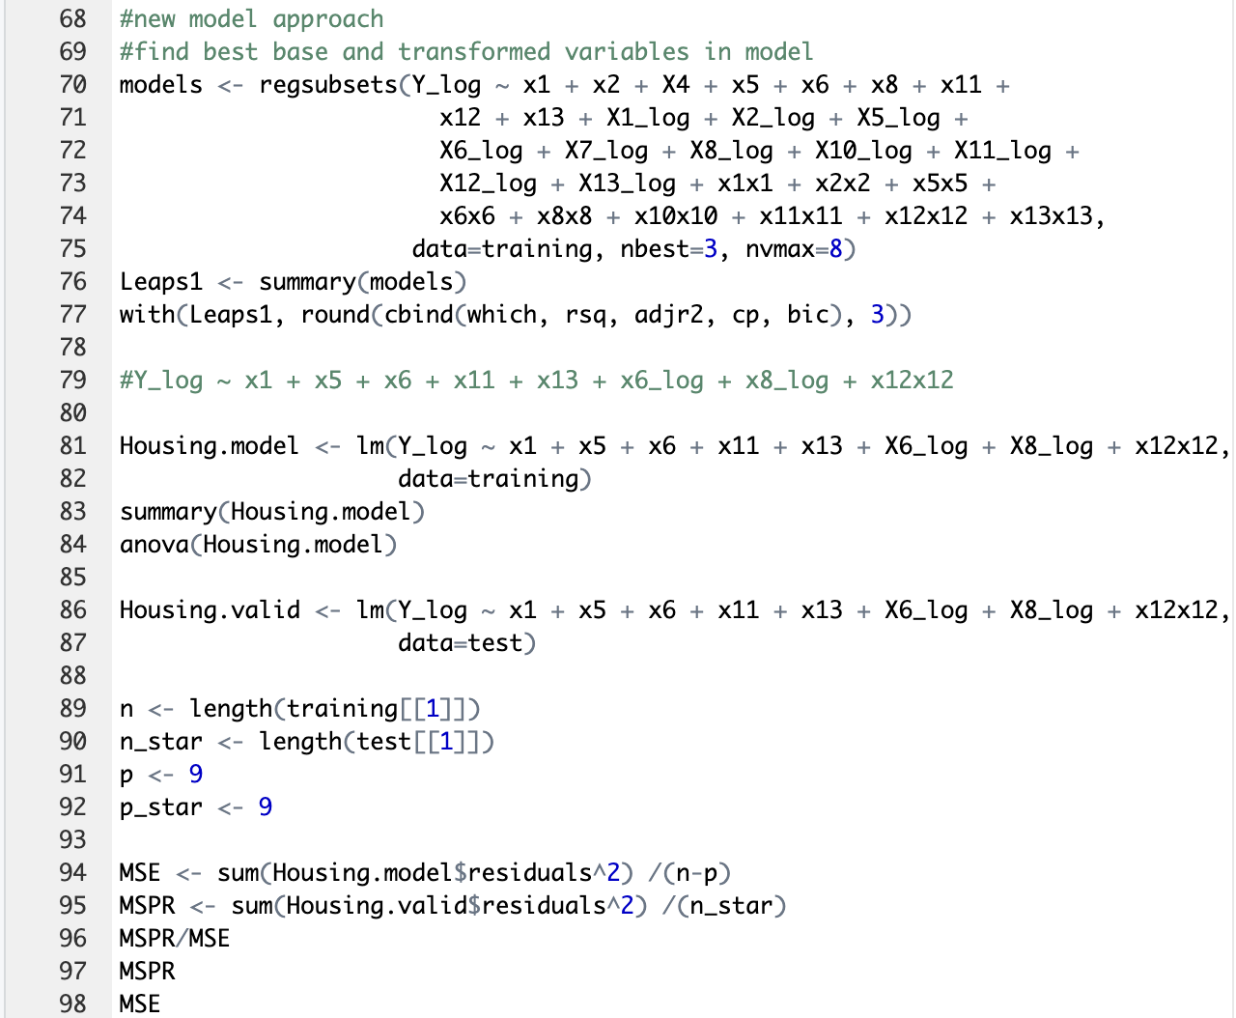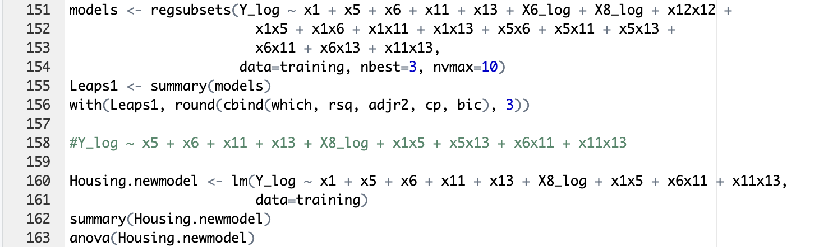

References
Harrison, David & Rubinfeld, Daniel. (1978). Hedonic housing prices and the demand for clean air. Journal of Environmental Economics and Management. 5.81-102. 10.1016/00950696(78)90006-2.

Kaggle Website
Boston Housing Price Prediction

